Synesthesia

🧠✨ What is Synesthesia?
# Source: AI Source: Provided by: [Data Path: Persons Table -> ID Column: 1, Name_En Column: Motasem Essam] -> From: [Chatgpt (GPT-4-turbo)] on [7/24/2025]
Synesthesia is a rare neurological condition in which stimulation of one sense involuntarily triggers another sense — so a person might see colors when they hear music, taste flavors when hearing words, or feel textures when seeing shapes.

📘 Definition:
# Source: AI Source: Provided by: [Data Path: Persons Table -> ID Column: 1, Name_En Column: Motasem Essam] -> From: [Chatgpt (GPT-4-turbo)] on [7/24/2025]
Synesthesia is a condition in which stimulation of one sensory or cognitive pathway leads to automatic, involuntary experiences in a second pathway.

🔍 Key Features:
# Source: AI Source: Provided by: [Data Path: Persons Table -> ID Column: 1, Name_En Column: Motasem Essam] -> From: [Chatgpt (GPT-4-turbo)] on [7/24/2025]
- Involuntary: It happens automatically, not by choice.
- Consistent: The associations don’t change over time.
(e.g., the letter “A” is always red for a specific person).
- Cross-sensory: It involves two or more senses mixing.

🧪 Examples of Synesthesia Types:
# Source: AI Source: Provided by: [Data Path: Persons Table -> ID Column: 1, Name_En Column: Motasem Essam] -> From: [Chatgpt (GPT-4-turbo)] on [7/24/2025]
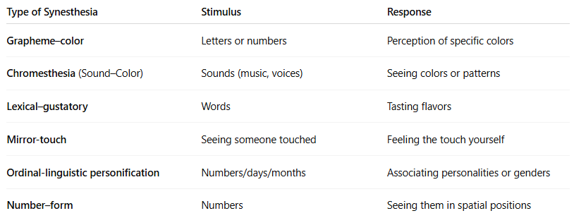

Type of Synesthesia | Stimulus | Response
Grapheme–color | Letters or numbers | Perception of specific colors
Chromesthesia (Sound–Color) | Sounds (music, voices) | Seeing colors or patterns
Lexical–gustatory | Words | Tasting flavors
Mirror-touch | Seeing someone touched | Feeling the touch yourself
Ordinal-linguistic personification | Numbers/days/months | Associating personalities or genders
Number–form | Numbers | Seeing them in spatial positions

🧬 Why It Happens:
# Source: AI Source: Provided by: [Data Path: Persons Table -> ID Column: 1, Name_En Column: Motasem Essam] -> From: [Chatgpt (GPT-4-turbo)] on [7/24/2025]
- Believed to be caused by extra connections between brain regions.
- May result from genetic traits.
- Often appears in childhood and continues through life.
- Not a disorder — many synesthetes consider it a gift or enhancement.

📊 Synesthesia vs Imagination:
# Source: AI Source: Provided by: [Data Path: Persons Table -> ID Column: 1, Name_En Column: Motasem Essam] -> From: [Chatgpt (GPT-4-turbo)] on [7/24/2025]
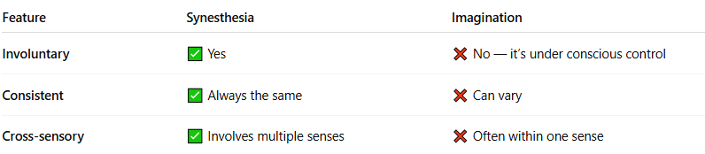

Feature | Synesthesia | Imagination
Involuntary | ✅ Yes | ❌ No — it’s under conscious control
Consistent | ✅ Always the same | ❌ Can vary
Cross-sensory | ✅ Involves multiple senses | ❌ Often within one sense

✅ Summary:
# Source: AI Source: Provided by: [Data Path: Persons Table -> ID Column: 1, Name_En Column: Motasem Essam] -> From: [Chatgpt (GPT-4-turbo)] on [7/24/2025]
Synesthesia is when one sense triggers another automatically — like seeing colors when reading words or tasting sounds.
It's a unique and real phenomenon experienced by a small percentage of people, and it reflects the incredible interconnectedness of the human brain.

